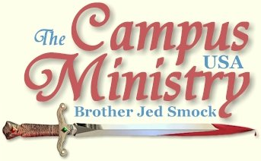
brojed@aol.com
brojed.org
Cell: 573-449-2428
Note From Sister Cindy: On Oct. 26th our family had the honor of being at Evangeline's promotion ceremony in Washington DC at the Chapel in Ft. Meade. We are very proud of our Sergeant McKay. Below are some pictures of the event, followed by Bro. Jed's account of the day and his journal from the week before.

Evangeline and her husband David before the ceremony
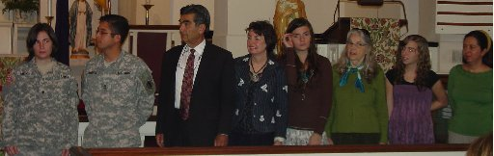
We all had the honor of standing with her: David, Bro. Jed, Cindy, Martha, Sis. Pat, Priscilla and David's Sister, Nelly

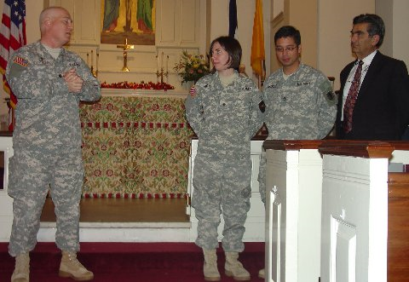
Chaplin Stroop commends Evangeline


Publishing of the Orders


Swearing in to the Noncommissioned Officer Corp

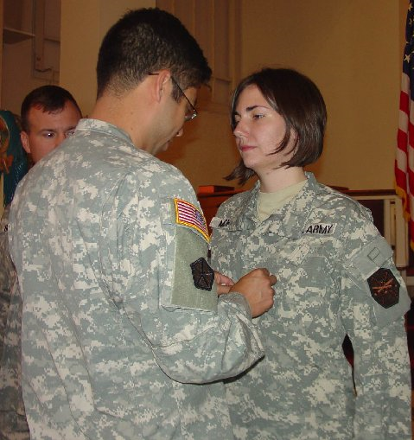
David Pins his wife, SGT McKay!

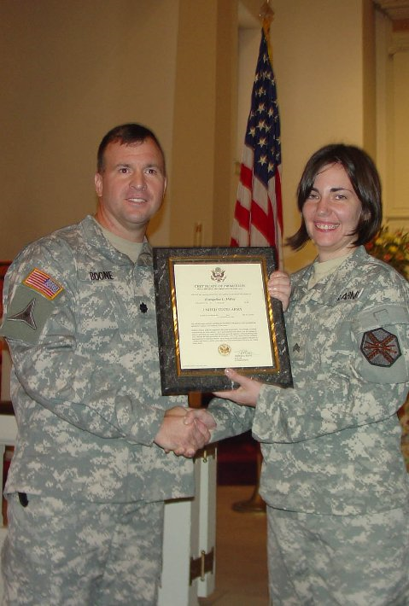
Evangeline is presented with her Certificate of Promotion from her Commander, COL. Boone
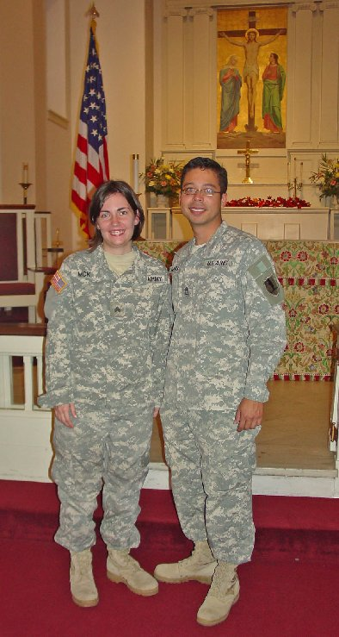
SGT Evangeline McKay and SFC David McKay...He still out ranks her!
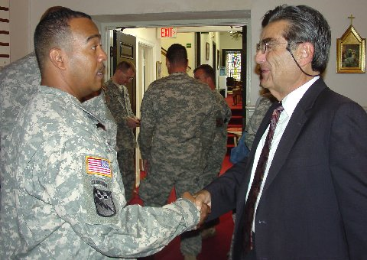
SFC Cargle, Evangeline's immediate boss, thanks Bro. Jed for the service of his daughter.
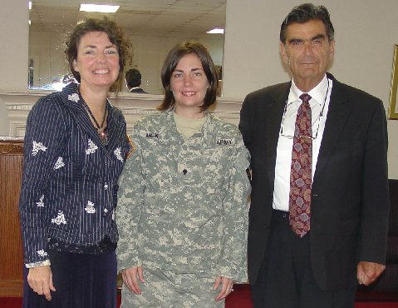
Proud Parents


SGT. McKay with Priscilla, Martha and the White boys

Evangeline's Promotion

Fort Meade, MD, October 26, 2009,

Cindy, Martha, Priscilla and I drove 16 hours yesterday from Columbia to Fort Meade to attend Evangeline’s promotion ceremony to Sergeant. Her superiors spoke very highly of her, “the ministry could not go on without Sergeant McKay; she is the rock.”

Evangeline’s commission was to “discharge carefully and diligently the duties of Sergeant and to uphold the traditions and standards of the Army. Soldiers of a lesser grade are required to obey your orders. According you accept responsibility for their actions.”

The Army expects complete and absolute obedience. God accepts nothing less. Yet many that teach in the name of the Lord make obedience optional. Most even dare to claim habitual obedience to the Lord is impossible.

Too bad the Church expects less than the Army.

I did not preach today. The ceremony was over the lunch hour. Afterwards, we toured the Maryland State Capital building where General George Washington resigned his commission as Commander in Chief of the Army to the Continental Congress on December 23, 1783. We stood in the very room where Washington addressed Congress which was then meeting in Annapolis. The following are excerpts from this speech:
“The Successful termination of the War has verified the most sanguine expectations, and my gratitude for the interposition of Providence, and the assistance I have received from my Countrymen, encreases with every review of the momentous Contest.
I consider it an indispensable duty to close this last solemn act of my Official life, by commending the Interests of our dearest Country to the protection of Almighty God, and those who have the superintendence of them, to his holy keeping.
Having now finished the work assigned to me, I retire from the great theatre of Action; and bidding an Affectionate farewell to this August body under whose orders I have so long acted, I here offer my Commission, and take my leave of all the employments of public life.”

"Reborn, Thanks!"
Missouri State University, October 19, 2009
Michael B. met me on campus. He and his wife teach at the university. He secured my permit and listened for about two hours. I started preaching at 11:45 on the steps of Strong Hall. Students slowly gathered. JT, who established the Church of the Flying Spaghetti Monster at MSU, soon arrived with some of his congregation. Last year he was working and not in school. JT and his friends were much more subdued this year than in the past. They did not dress as pirates, carry flags or make a commotion. They actually engaged in quiet and intelligent dialogue. Instead of interrupting as he has done in past years, JT would ask, “May I address that point?” Evolution vs. Creationism and the question of God’s existence were the main issues in the first hour.
In the mid-afternoon, J.T. stated, “Even if it was true, the crucifixion was an inefficient way for God to accomplish man’s salvation. I could come up with a better plan than that.”
“Oh, tell me what would you do?” I asked.
“Snap my fingers,” he replied.
I responded, “God cannot bring men into a relationship with him with a snap of his fingers anymore than you could. The Cross is such a powerful demonstration of love that it should influence all men to love God and love their neighbors. Alas, it does seem to have been a failure in actually resulting in changing most men.”
Another student said, “If the Cross has been a failure, why should I believe.”
“The Cross is a great success in the lives of those who believe. It transforms men’s characters and turns them from a life of selfishness to a live of benevolence. It is only a failure in the sense that most men refuse to embrace the Cross for it requires a life of self-sacrifice and men are determined to live a life of self-indulgence.”
At 4:30, I announced that I had to leave to attend the Bible Holiness Convocation in Neosho.
John asked, “Before you leave would you explain how you overcome lust?” I had noticed that John had been quietly listening for a few hours.
I quoted Job, “I have made a covenant with my eyes. How can I look upon a woman to lust?” I gave some practical advice on how trusting in Jesus to overcome sin requires self-control, prayer and fellowship.
I finally asked John if he had been born again. He said no; but that he would like to be. I went over to sit beside him and asked him to grip my staff as a point of contact with God and I led him in a prayer of repentance and faith. I received his contact information and told him that I was going to give his name to Michael B. He remembered him from last year and said that Michael has given him a Bible and that he had been reading it. I noticed in my motel room that he had written on his contact information note, “Reborn, thanks.” I rejoiced because confessions to what God has done are critical in establishing God’s work in one’s heart.
After I prayed with John, Ethan introduced himself as a Baptist Christian; and he also gave me his contact information. I encouraged him to invite John to a Bible Study. He said that he already had. Then Ethan said to me, “You are a brave man.”
The preacher’s text in at the Convocation included, “let us run with patience the race that is set before us (Heb 12:1)” I reflected that I have been running this race with perseverance for almost 4 decades. In the early 80’s I was one of the speakers at this annual Convocation. I have only visited once since then. At the end of the meeting a brother, who now taught at the Ozark Bible Institute and who remembered me from his student days, introduced himself. He said, “I thought when I saw you, ‘that is Jed Smock.’ I remembered the eye brows.”
Possessing the Promised Land
Missouri State University, October 20, 2009
There was one persistent heckler with whom I had to deal the whole afternoon. He was a representative of the Church of the Flying Spaghetti Monster. He raised a lot of questions and frequently made comments. But like a lot of atheists, he really did not want to listen to answers as he constantly interrupted me. He carried a Bible with him and did seem to have a better working knowledge of the Scriptures than most atheists.
The doctrine of free will answers the criticisms that atheists have concerning the morality and wisdom of our God. The atheist heckler claimed that God’s hardening of Pharaoh’s heart negated the doctrine of free will. I countered that God did not physically overpower Pharaoh to make him unwilling to free the Jewish slaves. But that God’s judgments had the effect of hardening Pharaoh. He would not accept that explanation. I acknowledged that on occasion God may overpower a man’s will, but that the Lord will not do this in the matter of a man’s salvation.
Michael B. brought out a friend, Greg, who took a day off from work to listen and pass out tracts. Greg spoke for about 15 minutes. I could tell that he has been schooled under Ray Comfort and the Way of the Master. Greg said that he witnesses in the streets on the weekends.
At 2:30 the crowd had dwindled to about 10. However, at the 3 PM break I gathered a new crowd of 50-75 and I preached until after 5 PM. The weather has been sunny and in the high 60’s to low seventies the last two days.
In the evening I attended the Bible Holiness Convocation in Neosho. The preacher spoke from Deut 1 & 2 and Numbers 13 & 14. He contrasted the spies who searched out the land with those who would possess the Promised Land. Victory over sin is the greatest blessing and promise of the Scriptures (Acts 3:26, Rom 12:1-2, 2 Cor 7:1). But there are too many spies among God’s people and not enough landowners. I have to deal with spies daily, including a Baptist girl today, who tell me we cannot possess a holy life; that the giant of lust and high wall of “our sinful nature” are too formidable to overcome in this life.
Where are the Joshuas and the Calebs, who are another spirit and will lead God’s people into the Promised Land of Holiness? Alas, today most despise holiness fearing that they will lose their children if they hold up a high standard. Ironically, God condemned the people to bear their whoredoms with forty years of wandering in the wilderness of sin until the older generation died and only Joshua, Caleb and the youth under 20 entered into the Promised Land. Like Joshua and Caleb I have been wandering in the wilderness with the people proclaiming holiness for 38 years. Hopefully, in two more years I can lead the multitudes to turn northward into Canaan’s Land and to live the life that God has commanded.
After the service Chuck A. introduced himself to me. He remembered me from his student days at Ozark Bible Institute. He said that I had greatly impacted his life. After his student days he became a missionary in a number of nations and that he often thinks of me and my example has been an inspiration. He is preparing to return to the Sudan.
I commend the Bible Holiness Convocation and the Bible Institute (65 students) for maintaining high standards of dress as so many movements of the spirit, churches and schools have gone the way of the Egypt in the area of outward appearance. Sometimes right dress can cover a sinful heart; but more often slothfulness and immodesty in dress reveal a wicked heart. The land that flows with milk and honey and lush grapes (holiness) is so much better than the leeks and onions of Egypt (sin).

Man or Brute?
Missouri Southern State University, October 21, 2009
It has been 20 years since I have been on this campus of about 5000 students. It has had strict limitations on free speech which have been recently lifted. I did have to sign in with Campus Security 24 hours in advance. Other than that, there were no problems.
I took my stand under the flag in front of the Student Union. A sorority was promoting breast cancer awareness by selling glasses of pink lemonade for fifty cents. I preached holding my staff; but I failed to get anyone to gather at the first break. I decided to do some Bible reading until the next passing. A reporter with a camera from the student newspaper asked for an interview. Afterwards, I returned to my car to get my sign which lists sins which makes men fit for Hell.
At the 1 PM break, students again were seemingly ignoring me as they passed. There was not a lot of traffic as the passage. I attempted to provoke the breast awareness girls by saying, “These boys are much too aware of your breasts. This campaign is just encouraging more focus on your private parts. College boys have a fixation on breasts and you girls have a fixation on the size of your breasts. If you really want to raise some money, charge these boys five dollars to touch you on the outside and ten dollars to touch on the inside. Then you might raise a significant amount of money. Many of the girls on this campus are allowing the boys to feel them up for nothing. Find some of these girls to volunteer; and let’s try to raise some real money for your cause.”
My satire did have the desired effect of bringing the girls over to talk. They were not as upset with me as I thought they would be. Several of the girls ended up requesting to pose with me for a picture with my sign. I always am agreeable to the picture taking sessions because I know my sign will be all over facebook in the evening.
With the exceptions of a few passing remarks, the students were civil. I never had more than 20 gather and mostly the crowd was closer to ten, but the ones I had were attentive.
One professing Christian girl kept insisting that what I was doing wasn’t accomplishing anything and no one was listening, etc., etc,. etc, like a broken record. I hear it over and over and over. Finally, a girl named, Angela, interrupted and said, “But he does have people’s attention. What he is doing is working.”
I assumed Angela must be a Christian. But later when I interrogated her concerning her faith she said that she was “torn,” concerning contradictions in the Bible and different interpretations of Christians. She had been raised an Episcopalian but had been attending an evangelical church. I tried to encourage her in the faith.
An atheist with a Nirvana t-shirt who idolized Kurt Cobain entered into dialogue with me. He fancied himself a scientist. He was fond of using the pronoun “we” instead of “I,” which is a sign of intellectual snobbery. I explained that Creationism makes man significant and life meaningful. But if evolution is true, then man is no more significant than a worm and life is meaningless. We come out of the primordial ooze and after 70 to 80 years we return to the ooze. Yet, we intuitively know that we are significant and life has meaning. We value our own life. We are constantly asking, ‘Why? What does that mean?’ Mere animals do not ask why, nor are they looking for meaning. We even affirm there is meaning when we say something is meaningless. For something to be meaningless, something else must have meaning. We know that life has value that is why we are sad when a loved one dies. If life is meaningless, then there is no reason to be sorrowful over death.”
The Kurt Cobain idolater answered, “I believe in evolution because it makes me feel good.”
I respond, “It’s not a matter of what you feel, whether it be evolution or creationism. Creationism supplies the motive for men to behave well. Creationism motivates man to act with dignity knowing he has an inherent dignity as a creature made in the image of God. If evolution is true, man has no more distinction that a mosquito or an ape which results in man acting like an animal. Under the evolutionary model there is no incentive to behave in a self-sacrificing matter. Why protect the weak when only the fittest survive according to natural selection? But we Christians recognize that all human life is sacred and worthy of being protected and promoted.”
Israel in making a calf in Horeb and worshipping the golden image, “changed their glory into the similitude of an ox that eateth grass (Ps 106:20).”
Evolutionists have changed man’s glory as a creature made God’s likeness into a beast of the jungle and a fish from the sea. What folly! And they think they are educated. I have not mastered the scientific arguments against evolution. The myth is so counter-intuitive that is should not have to be refuted by appealing to science.
IF WE SUFFER WITH CHRIST
University of Missouri, October 23, 2009,
Yesterday, I was rained out and drove five hours from Neosho, MO, through rain back home.
Pastor Allen S. from Kansas City had been planning for a few weeks to join me at the University of Missour with two of his friends. With the weather cloudy, windy and only in the mid forties, normally, I would have stayed at home to get caught up on office work. But they had already taken the day off from work to get the preaching experience, so we went out despite the poor weather. Pastor Allen has really taken hold of the message of holiness and confrontational evangelism since I held a revival in his church last summer. He also wanted me to instruct his friends, David and Delphine, on holiness. So before we went to campus, I led them in a study of Romans 6 and 1 John.
I started preaching at 12:45; but only a few stopped. One was CC, who I have probably mentioned before in my journal; she is one of my regulars. I reproved her for wearing her pajamas to class. Then I expressed my concern that she would get a chest cold because she was wearing an extremely revealing low cut blouse. Her excuse for wearing the pajamas was that she had worked late last night. I asked, “Where do you work, Hooters?”
I suggested to CC and Garrett, a non-student, who hangs around Speakers’ Circle that they join us inside for a Bible Study. CC’s alleged problem with God is that she had prayed that He would intervene to correct a bad home situation, which had ill effects on her younger siblings. She claimed that a loving God is obligated to correct such a bad situation. She concluded that there is no God since he had not removed her siblings from the home. Garrett had Moslem and Hindu friends and he could not imagine that God would let them go to Hell. I read Scriptures which I thought would help them; but they had to leave after about 20 minutes.
I suggested that Allen try preaching at the next break. I hoped that since he is a new face, that he might get students’ attention on a cold day better than me. Allen gave them 10 good reasons for NOT drinking; including that lots of booze makes one vomit.
I made a few comments to provoke interest as Allen preached. One woman was there with her baby. I yelled, “Good for you, young lady. That is why people are to have sex, to make babies. First you girls need to get a husband though.”
She walked off saying, that she had a husband.
“Great, keep up the good work,” I replied.
Allen had gathered about ten students.
Meanwhile, Colleen approached me and asked, “How many times do you have to get drunk before you are headed for Hell?”
Colleen had started drinking over the summer since her fiancé had broken off the relationship. I had a good witness with Colleen for about ten minutes.
Evidently, it was too cold for the students to listen to Allen. They were all gone within the time I talked with Colleen. We stayed out until 2:30; and decided to return to my home for more Bible study. I covered Romans 7 & 8, explaining that if we are the children of God, “then heirs; heirs of God, and joint-heirs with Christ; if so be that we suffer with him, that we may be also glorified together (Rom 8:17).”
Suffering with Christ is evidently necessary for our glorification. Suffering for righteousness sake is also required for our sanctification, “for he that hath suffered in the flesh hath ceased from sin (1 Peter 4:1)” The man who is reviled, persecuted, and hated does not think of sin. His mind is preoccupied with doing the Lord’s work. Suffering is a key that unlocks the door to holiness.
We had a joyous time singing hymns, praying, and praising the Lord. Cindy fixed us all Chili for dinner. The weather was cold but we had lots of good fellowship to warm the soul.
Delphine asked a good question, “How do you differ from Fred Phelps?
1. Phelps is a Calvinist. 2. It is my understanding that Phelps believes that homosexuals have been given over to a reprobate mind; and that there is no hope for them. I think they can be saved. 3. He is over the top in preaching at the funerals of the dead. 4. He is anti-military; I am pro military.

I did admit that I had never actually heard Phelps preach; so we need to be careful about judging him through the eyes of the media.
Pastor Allen and his friends said that Phelps only preaches condemnation. That he does not extend any mercy. Pastor Allen’s bishop had talked with Phelps, who admitted that he does not preach salvation to the sinners. We all agreed that the law needs to be preached to bring about conviction of sin.

